

Machine Learning-Music Recommendation

Progress Report

| Roll No. | Name of the Student | Name of the Program |
| --- | --- | --- |
| AU1940142 | Shail | ML |
| AU1940267 | Sahil | ML |
| AU1940034 | Varun | ML |
| AU1940109 | Jap | ML |

**Dataset Explored**

The dataset named data.csv has been explored by us in depth. We have described what each and every column in the dataset means. Having been listening to music ourselves a lot we are able to figure out a basic understanding about what a user wants to listen to in the future and based on which features would the user be wanting to listen to his/her next list of songs.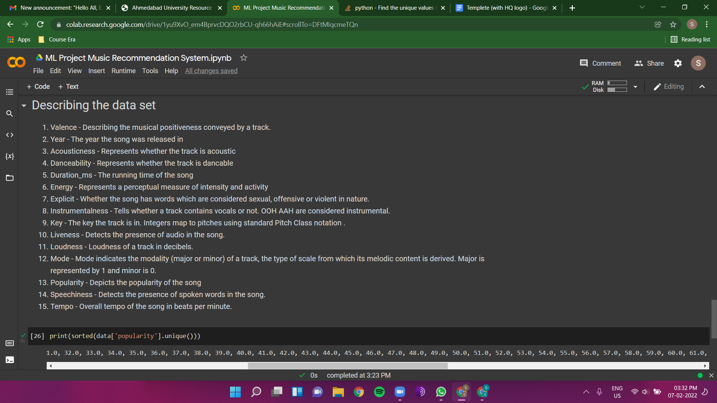

**Dataset Anomalies**

On describing the dataset we have discovered that there are 36,532 rows in the dataset. While most of the features have all of the values, it has been found that some columns have some missing values.

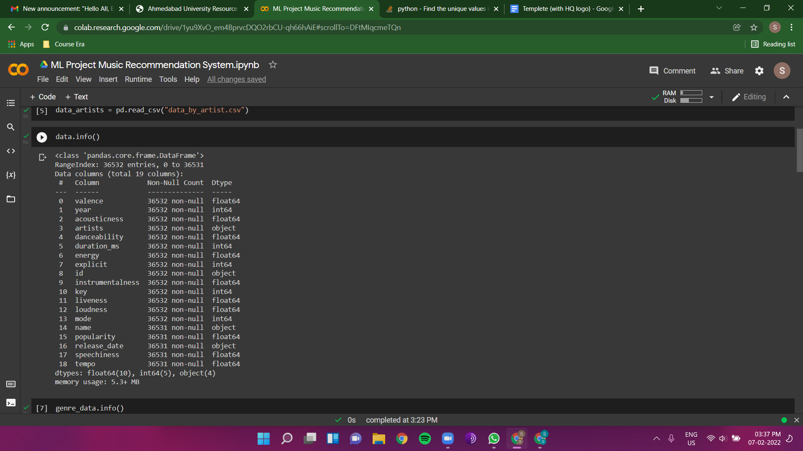

Since there is only 1 missing value in the columns we will be removing those rows with missing values. Since it won't affect the dataset much.

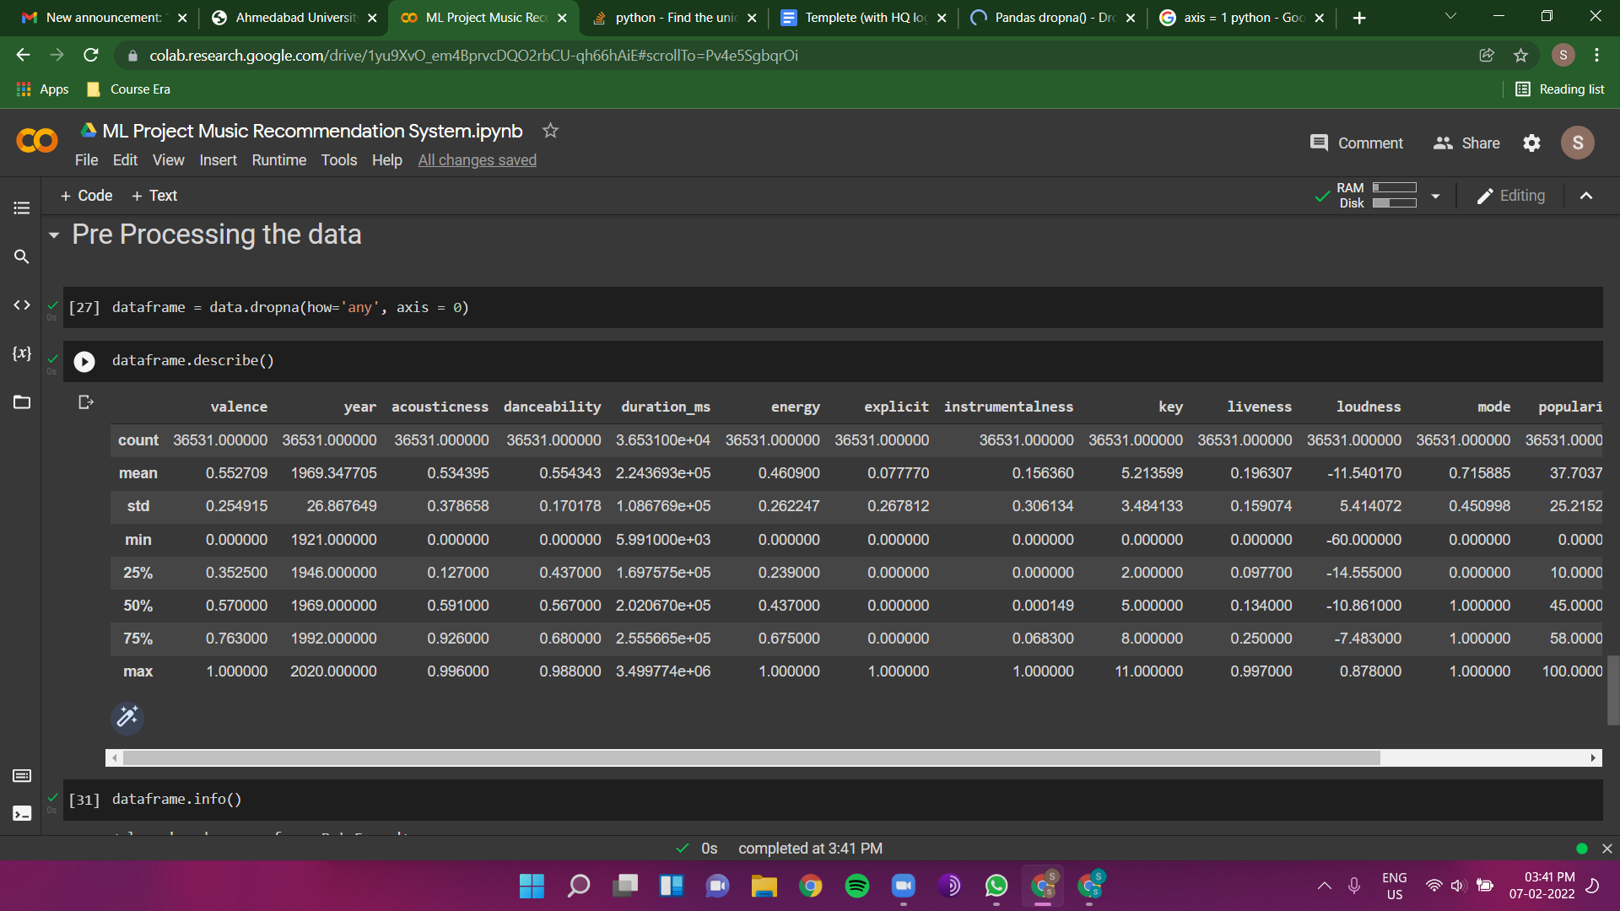

**Future work**

Apart from understanding the features we were able to think about some features of our own like repetitiveness of the lyrics, change in the rhythm etc. We will look to find out about these features in the next step if they are available to us.